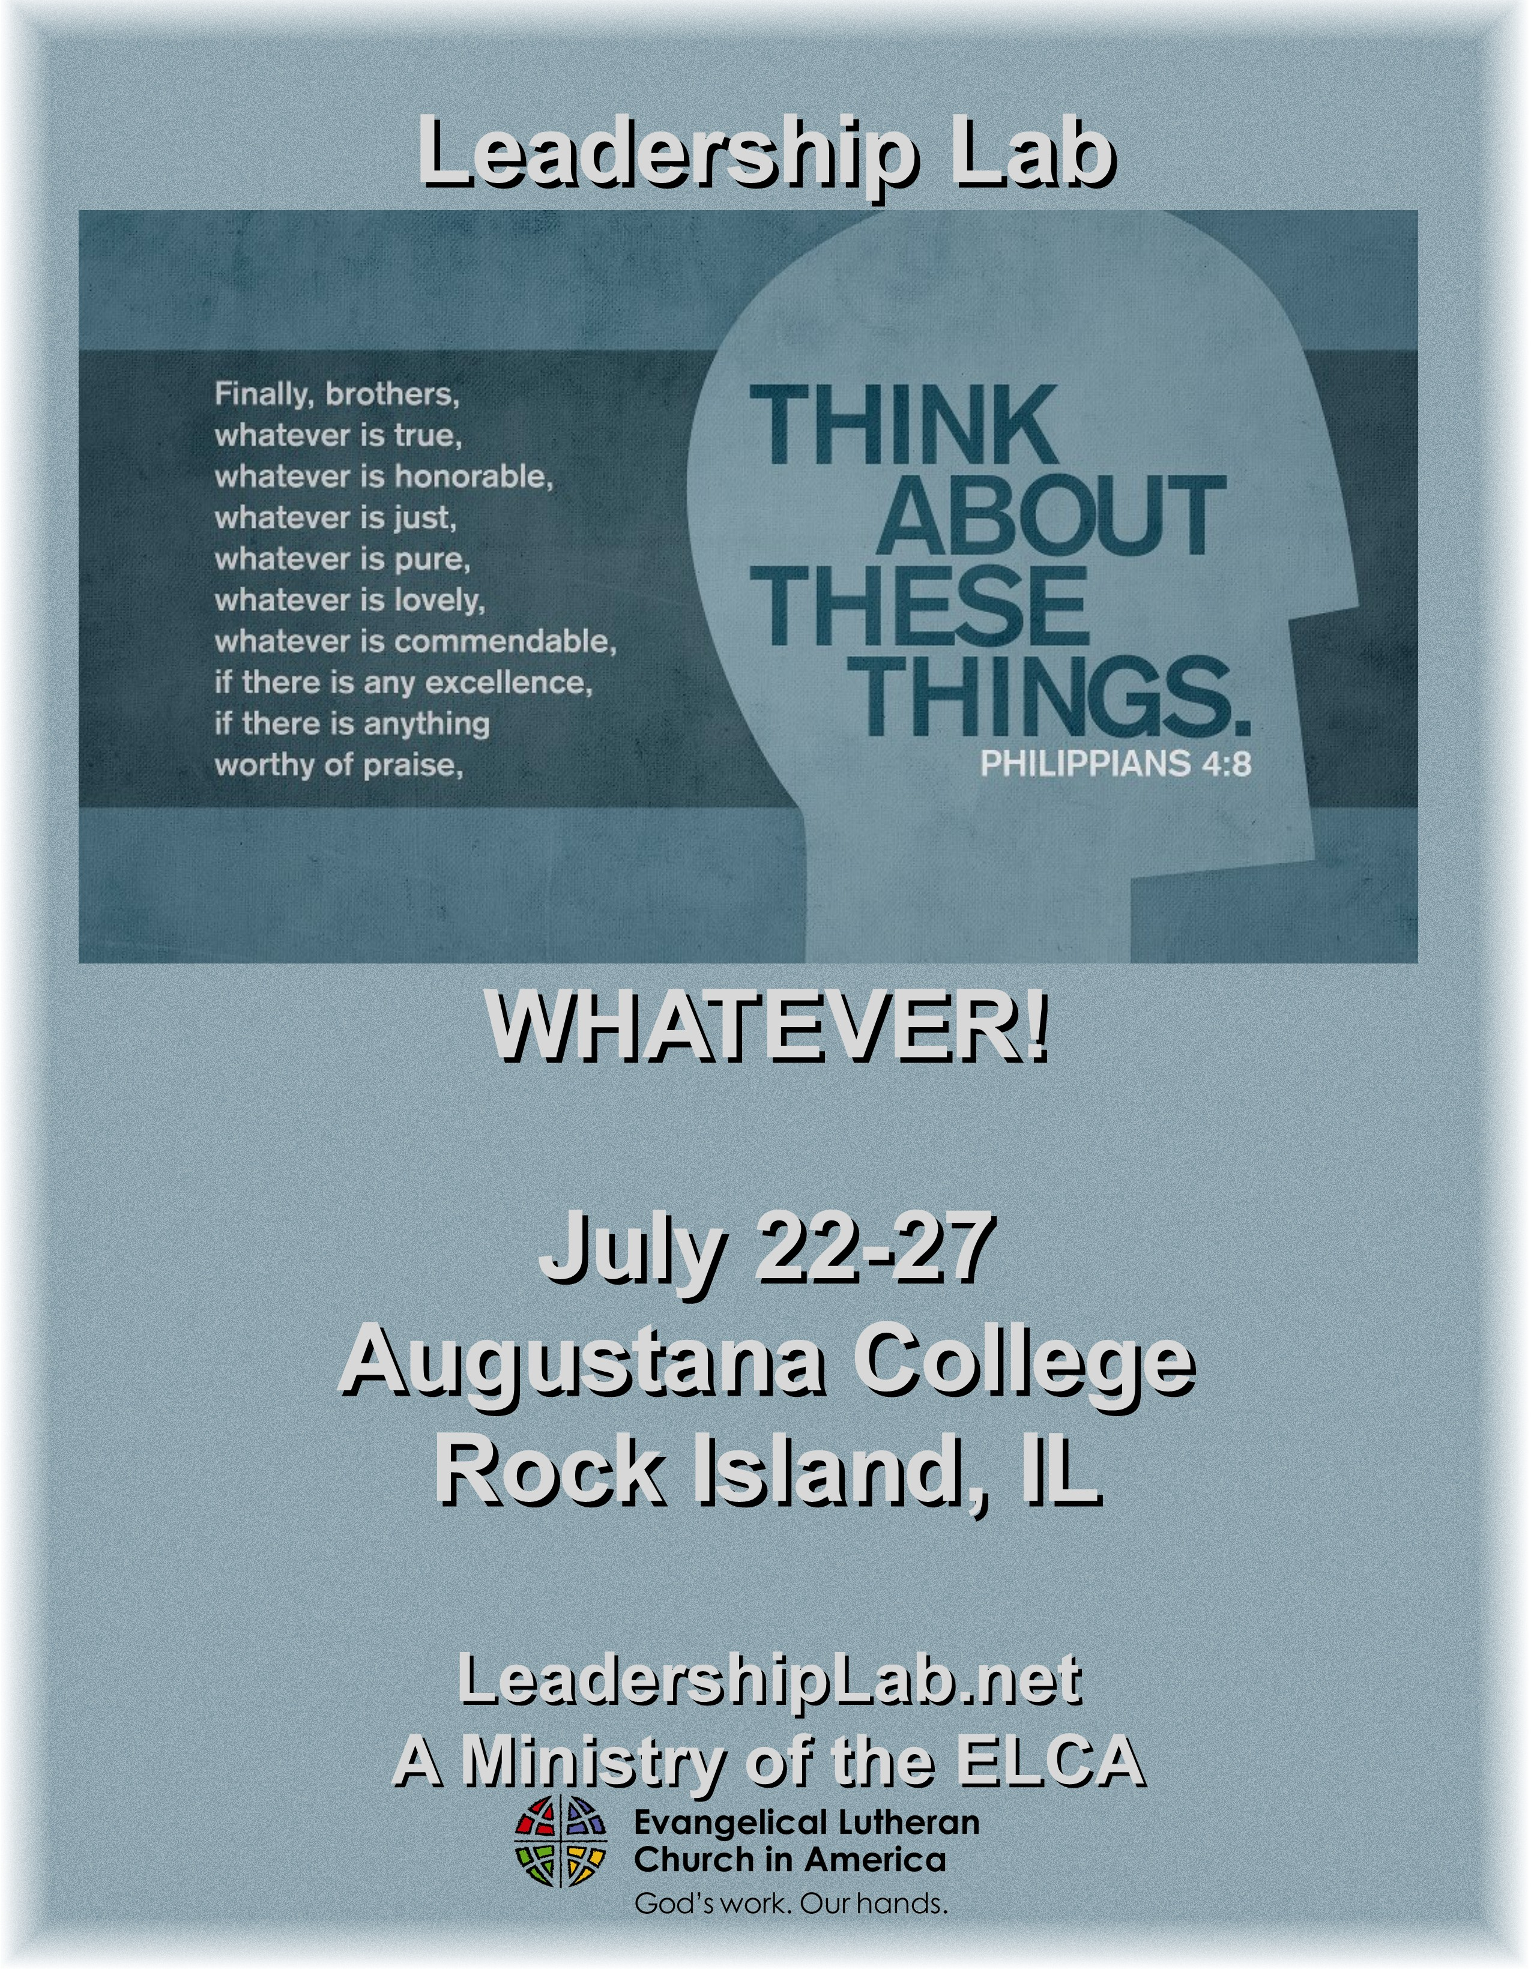
A Ministry of the ELCA
Central/Southern Illinois – Metropolitan Chicago – Northern Illinois

PLEASE COPY THE ENTIRE REGISTRATION FORM FOR EACH PERSON REGISTERING

WHAT IS LEADERSHIP LAB?

Leadership Lab is designed to assist youth acquire skills that will be useful in congregational, synodical and national youth ministry settings and in their local communities and the world. Each level of Lab is structured to help participants progress in their ability to be responsible youth ministry leaders and helps them grow in their awareness of God, self and others.

Participants must have completed the eighth grade;
Participants must complete the previous lab level before moving to the next level (i.e. must complete Basic before Advanced; Advanced before Phase 3; Phase 3 before Step Fourth);
No previous lab experience is necessary to attend Phase 3 for those who are entering their junior year of high school;
CROSSROADS – For anyone between the ages of 18 and 22. No prior Lab experience required, however you must have graduated from high school;
ADULT LAB – For anyone over 22. No prior Lab experience is required
Augustana College offers enough space so that we no longer need to limit the number of youth that Congregations wish to send to Lab. However, remember that Lab is NOT a place to send your whole youth group. Leadership Lab is a unique experience aimed towards those youth who have shown leadership potential. If you have questions or concerns about a particular youth's ability to fulfill the Lab experience, please be in contact with the Directors to address those concerns or issues.

Leadership Lab is an intense week of study, worship, and building relationships. The participants spend from 8:30 am –11:00pm each day in small and large group gatherings, planning, learning, prayer, and discovering where they are in their faith journey. While very spiritually rewarding, the week can be stressful and difficult. Participants need to know this ahead of time so that they can prepare themselves for this type of an experience. If you have any questions please feel free to be in contact with one or both of the Directors.

LEADERSHIP LAB HAS A ZERO TOLERANCE POLICY REGARDING DRUGS AND ALCOHOL.

Very Important Information

Registration Form: If your registration form/medical release/covenant is incomplete (this includes all signatures), then it, along with your registration fee will be returned. If this happens then you will not have a spot at Lab until a completed registration with full payment is returned.

Check In/Check Out: REGISTRATION OPENS ON MONDAY MORNING, July 22nd at 11:00 am in the Centennial Hall Lobby and closes at 1:00pm. The first session begins at 2:00 pm in Centennial Hall. If you aren’t going to be able to check in during this time, you must request late arrival in writing and have it signed by your parent/guardian and pastor. This must be approved by one of the Directors. Once you get to lab you may not come and go from the event.

You are expected to be at Lab by 1:00 pm on Monday and stay until check out at 1:00 pm on Saturday. If you can’t make this commitment, please prayerfully consider your registration. Closing worship on Saturday begins at 11:00 am and ends at 1:00 pm in Centennial Hall. If you need to leave before 1:00 pm on Saturday, this request must be made in advance, in writing, signed by your parent/guardian and pastor, and must be approved by one of the Lab Directors. Failure to do this may result in you not being allowed to return to lab the next year. Adults providing transportation to and/or from Lab are invited to the opening and/or closing celebrations.

Please Note Age Change: Effective in 2007 any youth having completed eighth (8th) grade can now register for Basic Lab. Please know that we are very mindful of age ranges when small groups are assigned.

Room Assignments/Rooms/The Campus: You will be roomed randomly with other labbers from your Lab level. You will probably not be roomed with someone you know. We do this so that you can “get to know” other labbers. We will not take roommate requests.

If you have special needs, it is important that you be in contact with one of the Directors so that proper arrangements can be made to accommodate you. It is very important that all participants must be self sufficient and able to see to their own needs and dispense their own medications.

Dress Code: Leadership Lab has a dress code that is enforced. No tank tops with spaghetti straps or tube tops for young ladies. Underwear is to be worn under clothing and is not to show. Shirts must fall at least 3 to 4 inches below the waistband of shorts or jeans. There is to be no skin showing between the top of your shorts/jeans and the bottom of your shirt. There will be no t-shirts worn with offensive or suggestive language. Shorts must fall at least 1 inch below your fingertips; excessively short shorts will not be tolerated. Shirts and shoes will be worn during celebration and where appropriate during Lab activities. Leadership Lab Directors and staff reserve the right to decide what is appropriate.

2013 Registration Deadlines and Registration Fees

Total Registration Amount of $370 - Postmarked on or before June 15th
After June 15th registrations will be accepted as space allows and at the discretion of the Directors. There will be an additional $25 charge for any registration that is accepted after June 15th.

There is also an early registration option where you can save $20.00 on your registration cost, but this option has changed a bit. You must fill out your registration form and medical release in full and enclose full payment with your early registration. There is only one registration form this year, so look to the bottom right of the form for this option. Early registrations are taken until April 30th, 2013. Please see the Directors with any questions.

Please go on line to www.leadershiplab.net and check out our new payment option. You can now pay by credit card. There will be an additional processing fee.

REGISTRATIONS POSTMARKED AFTER 6/15/10 WILL BE ACCEPTED AT DIRECTOR’S DISCRETION

Cost: See registration fee above. The registration fee includes lodging, meals from dinner on Monday through breakfast on Saturday, and program costs. Participants may wish to bring additional money for snacks, and college souvenirs. Very few Lab T-shirts will be sold at Lab, so if you want a T-shirt, order now. The cost is $15.00, payable in advance, with your registration.

Full Payment is due with your registration form at the time you register. Any cancellation must be made by June 30th. If you cancel by this date your church will receive a refund check in the amount of $150. All other registration monies are NON-REFUNDABLE. Any cancellations after this date will lose the full registration. Substitutions may be made until June 30th. Any registrations received without full payment will be returned. Any t-shirt not paid for at time of registration will not be ordered. If you do not indicate a size a large t-shirt will be ordered for you with limited substitutions available at Lab.

Scholarships: The Leadership Lab Memorial Scholarship Fund provides scholarships for youth wishing to attend Leadership Lab but who are unable to meet the financial requirements. Limited funds are available. If you are in need of assistance, please contact one of the Directors. Contributions may be made to the Leadership Lab Memorial Scholarship Fund and sent in care of one of the Directors. The scholarship fund is in memory of Pr. Joel Albers, Scott Rosenberger and Jim Graham.

ALL INQUIRIES NEED TO BE DIRECTED TO LEADERSHIP LAB DIRECTORS:

Cindy Svanda Pr. Ben Bergren PO Box 158 Trinity Lutheran Church
Ava, IL 62907 3201 Meadow Dr.
618/426-3377 - Home Rolling Meadows, IL 60101
618/201-7310 – Cell 847/385-1870 - Cell
618/687-7310 - Work 847/398-7122 – Church

LEADERSHIP LAB LEVELS:

BASIC LAB offers youth: Chris Thomas and Karen Wagner - Coordinators
their first experience with the Leadership Lab program;
the opportunity to learn skills in developing youth ministry goals and strategies;
the opportunity to broaden their understanding of faith and faith issues;
the opportunity to participate in the life of this unique Christian community;
assistance in recognizing and strengthening their gifts, and discovering new abilities;

ADVANCED LAB offers youth: Jennie Van De Velde and Pr. Mike Thomas - Coordinators
the opportunity to build on the foundation laid in Basic Lab as they work towards “fine tuning” their planning skills for youth ministry leadership with peer assistance, support and evaluation;
the opportunity to begin to learn and experiment with different leadership styles, while finding and honing their own unique skills.

PHASE III offers youth: Jason Fisher and Raylee Brown - Coordinators
the opportunity to explore the meaning of faith in unique and challenging ways;
the opportunity to use their leadership skills in their small group settings;

Youth are assisted by trained staff to assess and explore their own faith journeys, while helping them build their skills in working within a group setting.

STEP FOURTH offers youth: Julie and David Leacox - Coordinators
a time to gather in community for the mutual strengthening, enhancing and supporting of the Christian values taught to us in the gospel;
a time for intentional discernment of one’s spiritual gifts and their level of refinement, as they explore how those gifts and Christian values fit into and enhance their chosen life vocation;
a time for proclamation and demonstration that the message of the gospel is real and dynamic in ones living, as they are sent into the world as passionate advocates for God’s kingdom;
both the exit point from the Leadership Lab experience and also the entry point into the challenging adventure of servant hood.

ADULT LAB offers: Marissa and Pr. Matt Metevelis - Coordinators
The mission of Adult Lab is to provide adults with basic skills for congregational leadership of youth and family ministry. AL, like the youth levels, is a relational and experiential learning event.
- AL is designed for adults who are involved or believe they are called to be involved with youth ministry.
- AL is especially designed for volunteer lay leaders.
- AL teaches a model for planning youth events.
- AL provides a background in contemporary understandings of youth and family ministry.
- AL develops a list of resources for youth and family ministry.

CROSSROADS offers: Scott Vandermoon and Vanessa Young - Coordinators
In its fourth year, this level has been designed for young adults who are in the beginning or middle stage of a faith journey which is completely their own. This lab is designed to help participants take an introspective look into themselves, and decipher the gifts and talents that God has blessed them with. After given time to reflect on how God has blessed each of the participants, they will actively search out how God is calling them into career, vocation and active ministry within their everyday lives. The new level serves as an excellent opportunity for young adults to find out how God can use them in an ever changing world.

